A quantum clock for everyone
A new European consortium of universities and businesses aims to build ultra-precise clocks – not just for use in the lab, but in society as well
Clocks are important tools – not only in our everyday life, but also for technological applications and in science. In these areas, it is important that time is measured very accurately. The GPS in your car, for example, only works because it is guided by high-precision atomic clocks. Building even more accurate clocks than the ones currently available, and making them small enough to be easily transportable, would open up myriads of new technological and scientific opportunities. Using new developments in quantum mechanics, and uniting the know-how present in science and industry, the new European consortium iqClock sets out to achieve both of these goals.
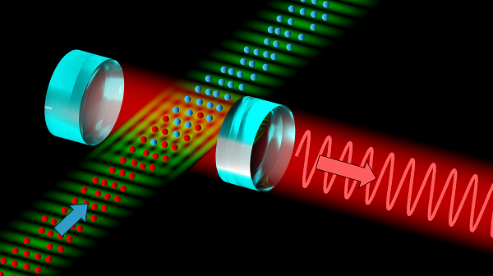  Figure 1. Schematic drawing of the superradiant optical clock that will be developed by the iqClock consortium. The input (blue arrow) is a continuous stream of ultracold strontium atoms; the output (red arrow) is a laser beam with a highly precise frequency used as reference for an optical clock. (Images available in larger resolution.) | 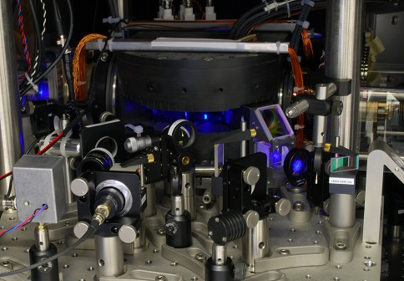  Figure 2. An ultracold cloud of strontium atoms in a vacuum chamber surrounded by electromagnets and laser cooling optics as used in the iqClock research. (Images available in larger resolution.)

Time plays an important role in our everyday life, filled with appointments and meetings. More and more often, technological applications also require a precise measurement of time. Navigation systems such as GPS, for example, can only guide you to your next appointment because the system’s satellites have a built-in atomic clock that allows the device in your car to determine its position within a few meters of precision. To meet your client, that precision is more than enough, but for many other applications this is not the case. For this reason, scientists around the world keep looking for better and better clocks.

The state of the art
In some laboratories, such clocks already exist: so-called optical atomic clocks. These clocks are the most precise scientific instruments created by humanity to date – if they would run for the entire age of the universe, fourteen billion years, they would go wrong by only a second. Just like in “ordinary” atomic clocks, in these optical equivalents the vibrations of an atom serve as a reference to measure time – simply because the frequency with which a certain type of atom vibrates is the same everywhere in the universe, at every moment. What makes an optical clock so much more precise than a traditional atomic clock, is that the frequencies used are more than a thousand times higher – in fact, these frequencies correspond to those with which visible light waves oscillate. This makes it possible to transfer the vibration frequency of the atoms to that of an optical laser – hence the name “optical clock” – which can then be used to make the clock tick.
As nice as such optical atomic clocks are, they have two major drawbacks. First of all, they are very difficult to build. Secondly, the resulting clocks fill entire laboratory rooms: they are large, heavy and not very robust. A consortium of European universities and businesses now plans to remove each of these drawbacks, with the aim to make ultra-precise optical atomic clocks available to society.

Superradiant clocks
Can optical clocks be made simpler? Recent developments show that the answer is “yes”. In normal optical clocks, the frequency of the optical laser is fine-tuned by shining its very stable laser beam on the vibrating atoms, observing how they react, and adjusting the laser frequency until the two vibrations match perfectly. However, physicists have now found a way to implement the idea of using lasers more easily – by simply letting the vibrating atoms themselves form the laser beam. That is, the laser beam that is produced consists of the very same atoms that are used to provide the reference frequencies that make the clock tick; a construction that has been dubbed a superradiant laser. The double use of the same atoms should make it much easier to construct optical atomic clocks: the atoms do not only provide very stable light, but moreover this light automatically has the correct frequency.
This idea would remove the first drawback of optical clocks – the fact that they are so complicated – but so far, superradiant clocks have never been built. However, the main building block, a continuous source of ultracold atoms – strontium atoms at only a few millionths of a degree above absolute zero, to be precise – was recently realized by a team of researchers led by Florian Schreck from the University of Amsterdam. At the same time, at the university of Birmingham, physicist Yeshpal Singh had suggested an initiative to develop industrial optical atomic clocks, planning to remove the second drawback – the large size and fragility of the existing clocks. Thus, nothing seemed to prevent atomic clocks from starting to play a role in our everyday life.

Building a consortium
Turning a proof of concept into actual working clocks is a long and tedious process though, that requires a close collaboration between science and industry. Schreck, Singh and Kai Bongs, Birmingham physicist and director of the UK National Hub for sensors and metrology, decided to team up with a large group of colleagues from Torun, Copenhagen, Vienna and Innsbruck to see if such a collaboration could be realized. On the industry side, several partners were equally interested in developing the ideas: Teledyne e2v, Chronos and British Telecom in the UK, Toptica in Germany, NKT Photonics in Denmark, and Acktar in Israel. With such a large base of interest among both academic and industrial partners, the decision was made to set up a broad European research consortium with the goal to bring optical clocks closer to the market. The consortium subsequently was financed as one of the first projects in the context of the Flagship Initiative for quantum technologies, a broad 10-year program which the European Union has decided to fund with at least one billion Euros. Out of this budget, the iqClock consortium, as the new collaboration was named, was funded for the next three years for a total of 10 million euros.

Navigation, geology and astronomy
The consortium’s aim is to make the optical clock technology fully transportable, so that by the end of the 10-year program it can be used in satellites, for example. This is not an easy process, but the benefits are enormous. Once the new clocks have become commonplace, they can be used to increase navigation system precision to the scale of centimeters, which would revolutionize the way in which we measure the Earth. But one can also look up instead of down: in astronomy, atomic clocks are used to synchronize telescopes all over the planet into what is effectively one giant telescope the size of the Earth. Transportable optical clocks are also great to detect gravitational waves, using satellites that are many thousands of kilometres apart. A more practical application lies in the synchronisation of telecommunication networks, increasing their performance. And then, of course, there is always the unexpected: when new technology becomes available on a wide scale, industry will inevitably find ways to employ it – in ways that we cannot even imagine today.
As Schreck himself phrases it: “Ten years from now, we will probably still be late for appointments with clients, but super-precise clocks may very well have penetrated society and changed the way we look at our planet and the universe.”

The Quantum Flagship kickoff
On October 29th, Europe will witness the start of a new and promising initiative known as the Quantum Flagship. This initiative is already positioning itself as one of the most ambitious of the European Union with a 1b € budget and 10-year duration funded by the European Commission. It will support large-scale and long-term research and innovation projects that will have the main goal of transferring quantum physics research from the lab to the market by means of commercial applications.
The Kick-off meeting of this initiative will take place in the historical site of the Hofburg in Vienna on October 29th and will summon many of the most relevant quantum physicists and technologists in Europe as well as policy makers, educators in quantum technologies, representatives of industry related to the quantum flagship as well as members of governing bodies. It is expected that several Ministries, State Secretaries or other representatives related to research, science, innovation areas from different countries will participate in the event.
The event will combine institutional sessions in which the initiative will be presented, with networking and technical sessions, to help network the different parties, including researchers from academia and industry, educators and decision makers. It has been organized in two distinct sessions: a morning session devoted to project presentations and networking, and in the afternoon, an institutional event which will entail the Festive opening of the Quantum Flagship, where distinguished academic, industrial, and political leaders will talk about the vision and the potential of quantum technologies.
More information about the Quantum Flagship and the Kickoff Meeting can be found at https://ec.europa.eu/digital-single-market/en/news/quantum-flagship-kickoff. If you are interested in attending the event, please register at that link. If you are interested in requesting interviews with the different spokespersons from the Flagship, please send an email to Alina Hirschmann, alina.hirschmann@icfo.eu.
On 25 October, the EC Communication Office will send out a separate press release about the Quantum Flagship initiative.

